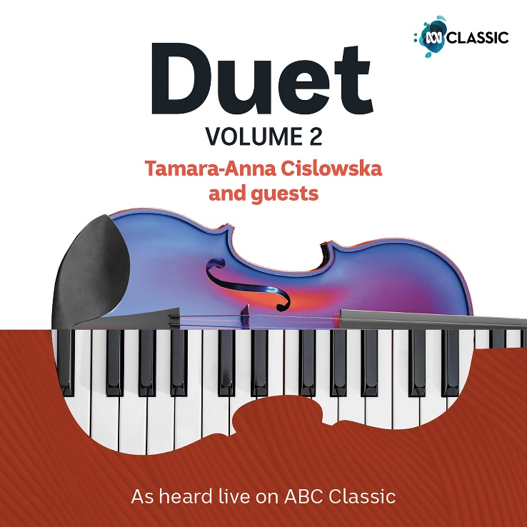
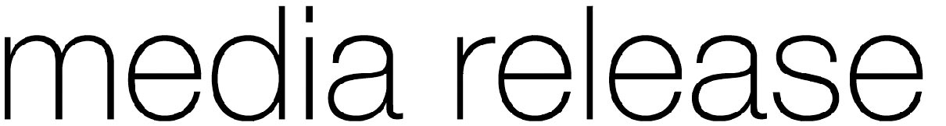

Duet Vol. 2
Tamara-Anna Cislowska and guests
More moments of musical magic
Each week on ABC Classic’s Duet program, award-winning Australian concert pianist
Tamara-Anna Cislowska welcomes a star into the studio to share an hour of music and conversation at the keyboard. It’s a chance to discover what makes great performers tick: how and why they do what they do, what inspires the music, and where the artistry is born.
The highlight of each program is a duet performance, live on air: music made in the moment, capturing the intimacy of new connections between stellar artists. This album brings together some of the most passionate, profound, joyous and sometimes quirky musical moments from the show, featuring 24 guest artists including Ben Folds, Karin Schaupp, Erin Helyard, Garrick Ohlsson and William Barton, in a rich kaleidoscope of musical colours from cello to saxophone, celeste to ophicleide and trumpet to didgeridoo.
‘Some of the guests featured in this album I met on the day, some I’ve known all my life,’ says Tamara. ‘All these musicians are precious to me and each brings their own experience, expertise, discipline and thoughtfulness to the music. Lend us your ears!’

Tamara-Anna Cislowska presents Duet on ABC Classic each Thursday from 3pm to 4pm.

Preview album here

Album available 16 September 2022
1CD + Digital download | ABCL0028
With eight ARIA no.1 albums, Tamara-Anna Cislowska is one of Australia’s most renowned classical pianists, performing and recording in Australia and internationally to critical and public acclaim. Soloist with the major symphony orchestras, arts and music festivals, and touring as guest soloist with the Australian Chamber Orchestra and CIRCA, Tamara’s accolades include international awards, ABC Young Performer of the Year, a Freedman Fellowship, and the 2015 ARIA Award for Best Classical Album.
www.tamara-annacislowska.com

TRACKLISTING

Ben Folds vocals & piano
1 FOLDS Capable of Anything

Umberto Clerici cello
2 TRAD. CATALAN / CASALS The Song of the Birds (El cant dels ocells)

Timothy Constable percussion
3 PIAZZOLLA Kicho

Dene Olding violin
4 SARASATE Playera

Erin Helyard celeste
5 BACH / HESS Jesu, Joy of Man's Desiring

Sally Walker flute
6 RIMSKY-KORSAKOV Theme from Scheherazade

Garrick Ohlsson piano
7 LISZT / CHOPIN Frühling (Spring)

Francesco Celata clarinet
8 KATS-CHERNIN Moth Eaten Rag

Shunske Sato violin
9 BACH Prelude No. 8 in E-flat minor from The Well-Tempered Clavier, Bk 1

Amelia Farrugia soprano
10 SATIE La Diva de l'Empire

Karin Schaupp guitar
11 VASKS White Scenery (Winter)

David Elton trumpet
12 BATTERHAM Trumpet Concerto:
II. Ballad

Alexander Briger violin
13 MOZART Serenade: Deh vieni alla finestra from Don Giovanni

Laura Vaughan viola da gamba
14 ORTIZ Recercada segunda

Kathryn Lambert piano
15 RACHMANINOFF Prelude in E-flat major, Op. 23 No. 6

Nick Byrne ophicleide
16 BIZET Je crois entendre encore
from The Pearl Fishers

Glenn Amer piano
17 GRAINGER Country Gardens

William Barton didgeridoo & vocals
18 BARTON Chant of the Earth

Nick Deutsch oboe
19 SCHUMANN Mondnacht
(Moonlit Night)

Gabriella Smart piano
20 MILHAUD Scaramouche:
II. Modéré

Christina Leonard saxophone
21 BOULANGER Nocturne

Ross Edwards piano
22 EDWARDS Frolic

Mary Doumany harp
23 DOUMANY Fjord

Kenny Broberg piano
24 VINE Threnody

Tamara-Anna Cislowska
piano, harpsichord (tk 14), ruined piano (tk 20)

