MEDIA RELEASE

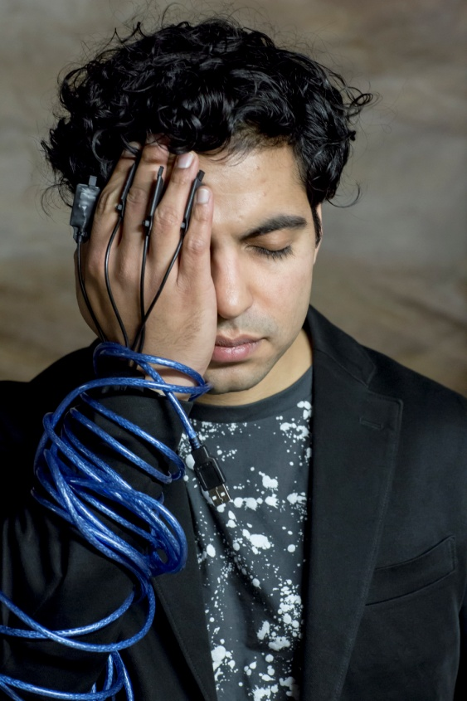

Internationally acclaimed Australian pianist and contemporary music specialist
Zubin Kanga
to perform
Cyborg Pianist
Music at the cutting edge of innovation

Perth, Sydney and Melbourne
WAAPA Tuesday 4 October
Melbourne Recital Centre Tuesday 11 October – in association with Melbourne Festival
Sydney Conservatorium of Music Saturday 22 October

Zubin Kanga, solo piano
Benjamin Carey, live electronics

Following his acclaimed 2015 DARK TWIN tour, award-winning London-based Australian pianist and contemporary music specialist Zubin Kanga returns in a program of newly commissioned works for piano and multimedia by some of the hottest composers from Australia and around the world.
“Kanga is an equally exciting pianist, effortlessly virtuosic and in complete command of this (quite literally) electrifying modern repertoire.” LIMELIGHT Magazine

Cyborg Pianist showcases music at the cutting edge of innovation, extending the body of the pianist to do the seemingly impossible, via a vast range of new technologies.

It features a range of leading Australian and international composers, all exploring new ways of extending the capabilities of a pianist using interactive multimedia. Patrick Nunn’s Morphosis uses 3D motion sensors attached to the pianists’ hands to shape the electronic sound in a work he describes as “Boulez meets The Matrix”.

Johannes Kreidler assembles videos of the pianist to create an orchestra of doppelgangers. Nicole Lizée tunnels into key moments in Alfred Hitchcock's classic films, drawing on DJ techniques to create a series of dreamlike and obsessive studies. Marcus Whale combines doom metal with aerial drone footage to explore remote Australian landscapes. Damien Ricketson pries open and submerges a piano work by Erik Satie in The Day After Drowning. Neil Luck creates a sci-fi vision of the future with mutant pianists. Adam de la Cour inserts the pianist into old hand-transplant-horror films. Finally, Kate Moore’s Bestiary is an electrified virtuoso epic, with the hands and feet of the pianist pushed to their limits.

Program

Marcus Whale (Australia) – Frontier for piano, electronics and video (2016) (World premiere)
Damien Ricketson (Australia) – The Day after Drowning for piano and live electronics (2016) (World premiere)
Johannes Kreidler (Germany) – Study for piano, electronics and video (2011) (Australian premiere)
Neil Luck (UK) – 2018 for piano and electronics (2016) (Australian premiere)
Adam de la Cour (UK) – Transplant the Movie! for piano, electronics and video (2016) (Australian premiere)
--interval--
Nicole Lizée (Canada) – Hitchcock Etudes (Australian premiere)
Patrick Nunn (UK) – Morphosis for piano, 3D sensors and live electronics (2014)
Kate Moore (Australia) – Bestiary for piano, digital pedals and live electronics (2016) (World premiere)

ABOUT ZUBIN KANGA

Zubin has performed at the BBC Proms, Aldeburgh Festival, Cheltenham Festival, London Contemporary Music Festival, Borealis Festival (Norway), Manifeste Festival (France), Sydney Festival, TURA Totally Huge New Music Festival, Metropolis New Music Festival, BIFEM and ISCM World New Music Days, as well as appearing as soloist with the London Sinfonietta and Melbourne Symphony Orchestra.

A specialist in contemporary classical music, he has collaborated with many of the world’s leading composers including Thomas Adès, Michael Finnissy, George Benjamin, Steve Reich, Beat Furrer, Ross Edwards, Nigel Butterley, and Elliott Gyger and premiered more than 60 works. He is a member of Ensemble Offspring, winner of a 2016 Art Music Award for 'Excellence by an Organisation', and has also performed with the Bang-on-a-Can Allstars, Ensemble Plus-Minus, Endymion Ensemble, the Kreutzer Quartet, Halcyon and Synergy Percussion, as well as performing piano duos with Rolf Hind and Thomas Adès.

Zubin was the winner of the 2012 APRA-AMCOS Art Music Award for ‘Performance of the Year’, the Michael Kieran Harvey Scholarship and the Limelight Award for Best Newcomer in 2010. His recent recordings include Not Music Yet (Hospital Hill Recordings), Orfordness (Metier) and Piano Inside Out (Move Records), which was nominated for Best Classical Album at the Australian Independent Music Awards.

Zubin is currently a post-doctoral researcher at the University of Nice and IRCAM, Paris as well as Research Fellow of the Royal Academy of Music, London, where he completed his PhD. His research on new approaches to performer-technology interactions is published widely.
zubinkanga.com

Venue WAAPA Music Auditorium
Date & Time Tuesday 4 October at 7.30 pm
Bookings Online or call (08) 9370 6895

Venue Melbourne Recital Centre
Date & Time Tuesday 11 October at 6 pm
Bookings Online or call (03) 9699 3333

Venue Sydney Conservatorium of Music
Date & Time Saturday 22 October at 7.30pm
Bookings http://cyborgpianist.eventbrite.com.au

FURTHER INFORMATION / INTERVIEWS / IMAGES /VIDEOS

For more information please contact:
Jacqui Bonner E: jb@jacquibonnermarketing.com P: 0411 473 198
Jacqueline Thomas-Piccardi E: jtp@cinqueartistmanagement.com P: 02 9929 2978

For images visit: https://www.dropbox.com/sh/zh9rg29nv26t2bd/AAAsO7s5ltTEZceoZEeIwVl4a?dl=0

For footage of past performances please click here http://www.zubinkanga.com/listenwatch/

